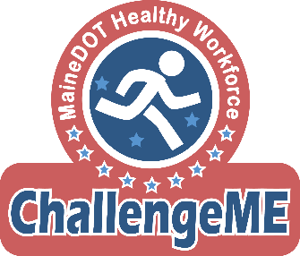

2021 Seasonal Readiness Program

The Seasonal Readiness Program has been a long-standing tradition for Maine DOT employees. The results achieved have been extraordinary and have improved year after year! This year will be different in comparison to previous years as we will not be providing or allowing on-site trainings, sessions, or workouts due to COVID-19.

**The entirety of the 2021 Seasonal Readiness Program will be performed on work-breaks or personal time**

*Before starting or participating in an exercise program, consult your physician*

Please reach out with any questions, concerns, or guidance with the fitness testing protocol, workout regimen, and/or modifications.

Contact Information
- Benjamin Ludwig
- MaineGeneral Workplace Health

Phone: (207) 621-7557
- Email: Benjamin.Ludwig@MaineGeneral.org

Why we do this!
To improve health and prepare employees for more active labor demands; getting our over-exertion injuries to ZERO.

What to expect:
- The Seasonal Readiness Program is fitness program aimed to help improve health and reduce injuries for Maine DOT Workers.
- The program takes place at home or on break-time. The workouts take 30 minutes. Start with 1 day per week and work up to 3 days a week.
- The design of the fitness routine is to prepare workers for the vigor associated with their daily job tasks.
- The fitness routine is a whole body workout targeted at improving cardiovascular endurance, muscular strength and endurance, flexibility, balance and agility.
- Participants in this program have recorded zero overexertion injuries every single year.

The Exercise Routine
This six-week bodyweight workout is designed to improve fitness in less time, without any equipment.
Always start with the WARM UP portion of the routine. Warm-ups help prevent injuries and allow you to perform your workout at a higher intensity, leading to greater performance gains and improvements.

As you progress through the six weeks, you will be able to increase the intensity of your workout. Before attempting more difficult exercise variations, be sure of your form is and that you are able to perform the exercise at level 1 for the entire timeframe.
- Levels of intensity:
  - Level 1 = standard
  - Level 2 = moderate
  - Level 3+ = advanced

The COOL DOWN for this routine consists of walking for 5 minutes to recover from the workout. The importance of a cooling down immediately after a workout is as important as warming up! After physical activity, your heart is still beating faster than normal, your body temperature is higher, and your blood vessels are dilated. Sudden stoppage of physical activity can results in adverse physical symptoms like:
- Lightheadedness
- Nausea
- muscle strains

Components of Health & Fitness:
- Cardiovascular Endurance
  - Exercises such as swimming, biking, jogging, skiing, walking or similar activities reduce the risk of coronary artery disease, aid in weight control, and increase your cardiovascular endurance, which (simply stated) is the ability to do repeated work without getting winded. This increase in energy makes you feel better and more productive.

- Muscular Strength/Endurance
  - Strong and enduring muscles are important for carrying out everyday tasks and can enhance work performance. They also can help to keep the body in proper alignment, prevent back and leg pain, and provide support for good posture.

- Flexibility/Balance
  - Flexibility and balance become more important as people spend a lot of time in a sitting position or being inactive and their joints stiffen up. Stretching your muscles increases flexibility and allow for a greater freedom of movement. Flexible muscles can also increase physical and mental relaxation, release muscle tension and improve your daily performance.

Warm Up

Perform 1 round of all of these exercises:
- Marching High Knees | 60 seconds
- Side to Side Reach | 60 seconds
- No-Jump Jumping Jacks | 60 seconds
- Arm Circles – Forward | 30 seconds
- Arm Circles – Backward | 30 seconds
- High-Knee Pull (alternating) | 30 seconds
- Ankle Pull-Back (alternating) | 30 seconds
- Calf & Leg Stretch | 15 seconds each leg

Workout

Perform 1-3 rounds of the following exercises:

- Body Weight Squats  - Level 1 – Hands in front of body  - Level 2 – Fingers to floor  - Level 3 – Palms to floor  - Level 4 – Single leg (alternating) | 30 seconds
- Push Ups  - Level 1 – Wall  - Level 2 – Secured Table or Chair  - Level 3 – Floor | 30 seconds
- Steam Engine | 30 seconds
- Alternating Reverse Lunges  - Level 1 – Hands on hips  - Level 2 – Hands overhead  - Level 3 – with Twist  - *Level 4 – Skips* | 30 seconds  *15 seconds each leg
- Mountain Climbers  - Level 1 – Wall  - Level 2 – Secured Table or Chair  - Level 3 - Floor | 30 seconds
- High-Knees with Open Arm Extentions  (“Seal-Jacks” without a jump) | 30 seconds
- Plank Hold**  - Level 1 – Straight Arm on hands  - Level 2 – On forearms  - *Level 3 – Side Plank on elbow  - *Level 4 – Side Plank straight arm | 30 seconds  *15 seconds each side  **Tip: Performing any variation of the Plank Hold from the knees with the same “flat-back” form is a perfectly acceptable modification**
- Calf Raises  - Level 1 – Both feet  - *Level 2 – One foot at a time | 30 seconds  *15 seconds each leg
**Rest for 2 minutes and repeat exercise circuit**
Cool-Down: Walk at a slow pace (5 Minutes)

Exercise Index
Warm-up
Marching High Knees Side to Side Reach
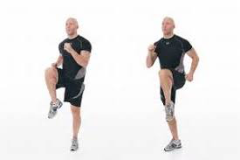
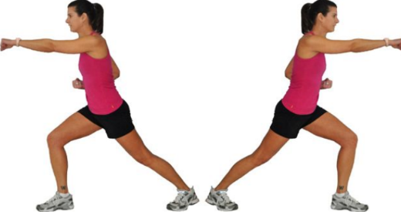

Jumping Jacks (no jump) Arm Circles (forward /backward)
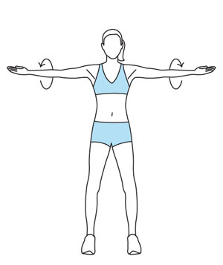
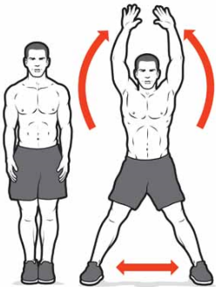

Alternating Standing Knee Pull Alternating Standing Ankle Pull
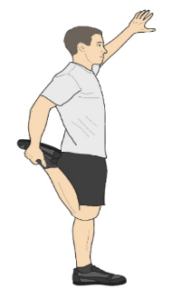
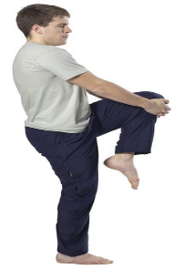

Workout

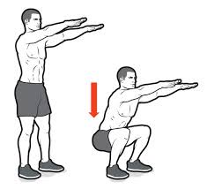
Body Weight Squat
- Stand with your feet shoulder width apart.
- Begin the movement by bending your knees and hips, sitting back with your hips.
- Lower the body down until thighs are close to parallel with the floor.
- Allowing the chest to learn forward, keep your back straight and head up, eyes looking forward.
- Do not allow knees to go past your toes.
- Increase intensity by keeping arms down and touching the floor with your fingertips (level 2) or palms (level 3).

Arms in Front Single Leg Squat
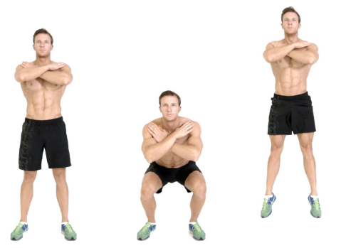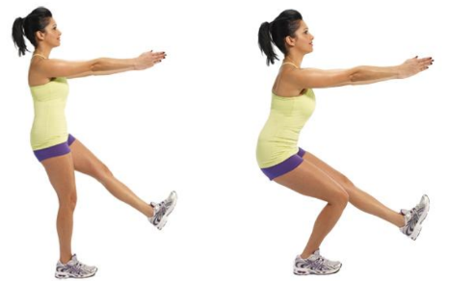

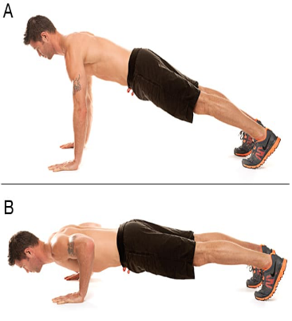
Push Up
- When down on the ground, set your hands at a distance that is slightly wider than shoulder-width apart.
- Your head, back, hips and legs should be flat like a table. Think of your body as one giant straight line – from the top of your head down through your heels.
- Feet should be hip width apart.
- Start with arms extended, elbows slightly bent.
- Lower body so upper arms are parallel to the floor, table, or wall.

Wall Push Up Table Push Up
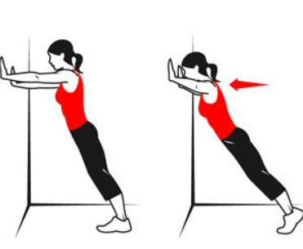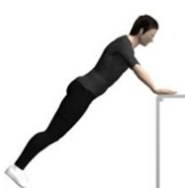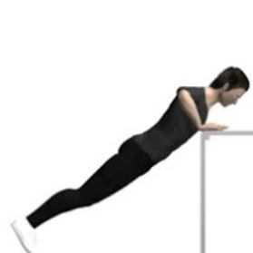

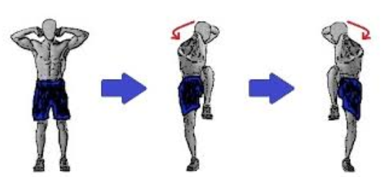
Steam Engine
- Stand tall with feet shoulder-width apart.
- Place your hands behind your ears with elbows in-line with your shoulders.
- Raise your left knee up and simultaneously bring your right elbow toward your knee.
- Return upright and lower knee down before repeating on the other side. Repeat with right leg and left arm.

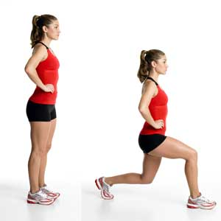
Alternating Reverse Lunges
- Stand with your feet hip width apart.
- Take a large step back with your right foot.
- Keep head and chest upright and lower hips to the floor.
- Right knee may bend as you lower. Go down as far as you can without touching your knee to the floor. Keep left knee from going past your toes as you lower.
- Lift body up returning to starting position and repeat by stepping back with opposite foot.

Lunge hands in Air Lunge with Twist Lunge with Skip
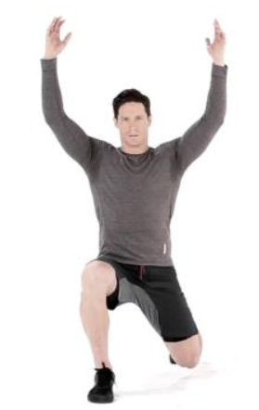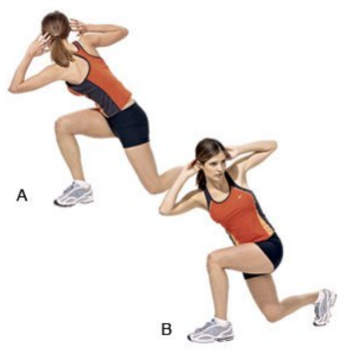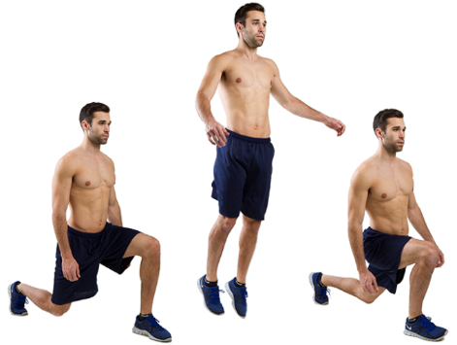

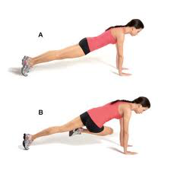
Mountain Climbers
- When down on the ground, set your hands at a distance that is slightly wider than shoulder-width apart.
- Your head, back, hips and legs should be flat like a table. Think of your body as one giant straight line – from the top of your head down through your heels.
- Feet should be hip width apart.
- Keep arms straight, elbows slightly bent. Hold this position
- Bring one knee up to chest, pause and return. Repeat with opposite leg.Work to keep body in a straight line and maintain plank position.

Mountian Climbers on Wall Mountain Climbers on Table
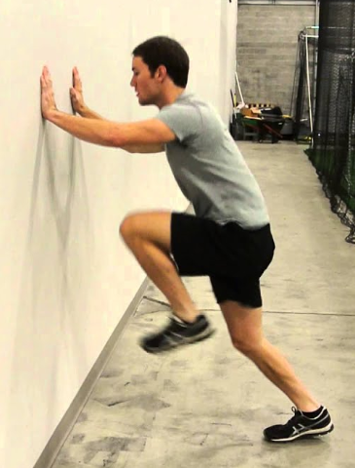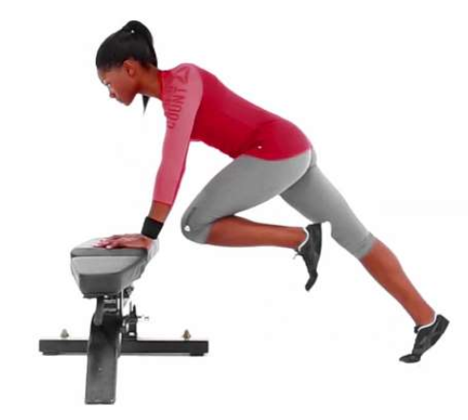

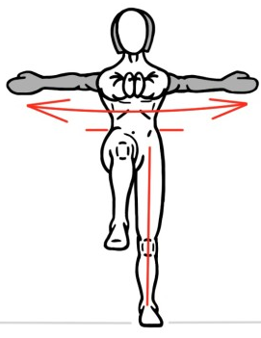
Standing High Knees with Open Arm Extension
- Standing in an upright position, arms parallel to the floor and straight, bring one knee up and close your hands in front of you (keep arms straight).
- As you lower your knees down, open your arms wide. Repeat with opposite knee.

Plank
- When down on the ground, set your elbows and upper arms in line with your shoulders.
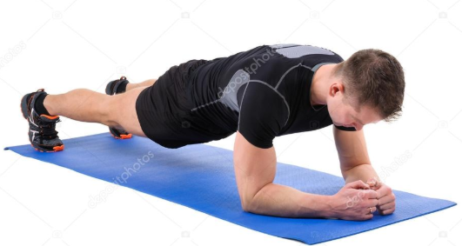
  - Alternative to laying on elbows. When down on the ground, set your hands at a distance that is slightly wider than shoulder-width apart. Keep arms straight, elbows slightly bent.
- Your head, back, hips and legs should be flat like a table. Think of your body as one giant straight line – from the top of your head down through your heels.
- Feet should be hip width apart.
- Hold this position.

Side Plank – on elbow Side Plank – straight arm
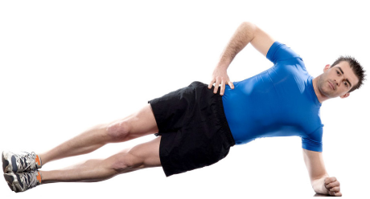

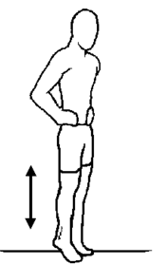
Calf Raises

How to perform Calf Raises
- Stand tall with feet hip width apart.
- Lift heels as high as you can while going up on your toes, as much as your ankle flexibility and balance allows.
- Push evenly through the entire width of your foot.
- Don't push off from your big toe or the outside edge of your feet.
- Lower heels down just before they rest on the floor.

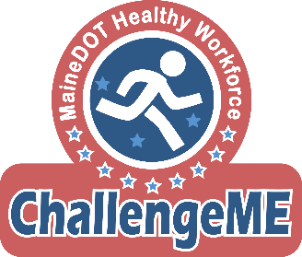

PERSONAL RELEASE FORM
Seasonal Readiness Program

I,_____________________________________________________(print full name), will be participating in the seasonal readiness program which is being offered as part of Maine Department of Transportation’s ChallengeME health promotion and wellness program.

I agree that my participation is voluntary.

I understand that there are inherent risks to participating in fitness testing and in an exercise program, and I hereby affirm that I am in good physical condition and do not suffer from any problems that would prevent or limit my participation in this program. I have/will discuss any health concerns with my personal healthcare provider prior to participating in this program.

Signature:_______________________________

Date:___________________________________

Send original to Janice Arsenault at DOT Headquarters.
Trainers may make a photocopy and give to participant at the participant’s request.

Exercise Session Attendance Sheet

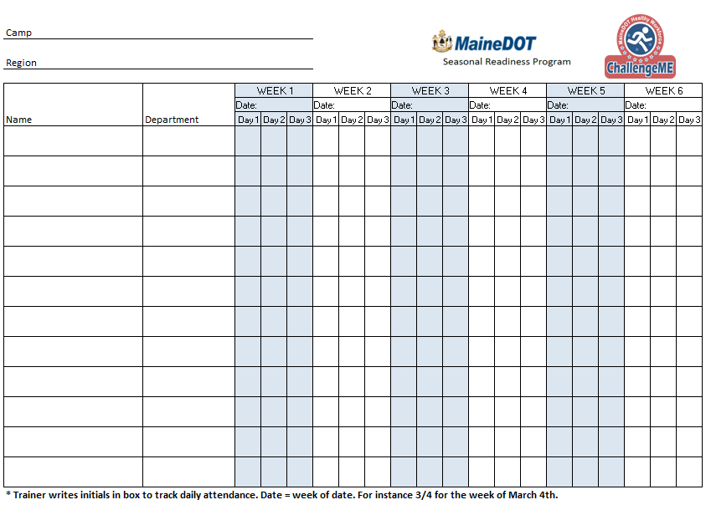

Fitness Assessment Instructions

*Please note: the Fitness Assessment is an optional component for the 2021 Seasonal Readiness program*

Fitness Assessments should take place the week prior to starting the six-week fitness routine (pre-test) and the week following the fitness routine (post-test). The purpose of the assessment is to evaluate the effectiveness of the Seasonal Readiness Program and show change in individual fitness levels. Trainers will conduct these assessments in a group format. Participants will partner up during each assessment to support partner and count repetitions.

Participant Preparation
- Wear comfortable clothing.
- Wear appropriate shoes for walking / running.
- Participants should use their usual walking aids during the 6 minute walking test
  - Cane, walker, etc.
- A light meal is acceptable before early morning or late afternoon tests.
- Participants should not exercise 2 hours before the testing session.

Pre Test Instructions
- Provide overview of the Seasonal Readiness Program to all participants.
  - Explain role as a trainer for this program.
  - Review the plan for the fitness testing session with participants.
- Distribute and explain the Personal Release Form to all participants.
  - Participants read, print name, sign and date Personal Release Form.
  - Trainer collects Personal Release Forms.
- Trainer distributes Fitness Assessment Data Form.
  - Participants completes top section of Fitness Assessment Data Form.
  - Participants will enter values after each test
  - Participants partner with another participant for all tests except weight measurement and 6-Minute Walking Test. Partners support each other and count repetitions.
- Trainer takes each participants’ weight (notes weight taken with or without shoes)
- Trainer administers 6-Minute Walking Test.
- Trainer administers 60-Second Squat Test.
- Trainer administers 60-Second Push-Up Test.
- Trainer administers 60-Second Half Sit-Up Test.
- Trainer administers Sit and Reach Test.
- Trainer collects Fitness Assessment Data Forms from all participants.
  - Trainer may provide a copy of the Fitness Assessment Data Form to the participant at the participant’s request.
  - Trainer thanks everyone for his or her participation.
- Trainer sends Personal Release and Fitness Assessment Data Forms to Janice Arsenault.

Post Test Instructions
- Ask and record feedback about Seasonal Readiness Program from participants.
  - Review the plan for the fitness testing session with participants.
- Trainer distributes Fitness Assessment Data Form.
  - Participants completes top section of Fitness Assessment Data Form.
  - Participants will enter values after each test
  - Participants partner with another participant for all tests except weight measurement and 6-Minute Walking Test. Partners support each other and count repetitions.
- Trainer takes each participants’ weight (notes weight taken with or without shoes)
- Trainer administers 6-Minute Walking Test.
- Trainer administers 60-Second Squat Test.
- Trainer administers 60-Second Push-Up Test.
- Trainer administers 60-Second Half Sit-Up Test.
- Trainer administers Sit and Reach Test.
- Trainer collects Fitness Assessment Data Forms from all participants.
  - Trainer may provide a copy of the Fitness Assessment Data Form to the participant at the participant’s request.
  - Trainer thanks everyone for his or her participation.
- Trainer sends Fitness Assessment Data Forms to Janice Arsenault.

Fitness Assessment Data
Seasonal Readiness Program DOT 2021

Name: __________________________________ Region: ________________________________

DOT Camp Location: _______________________ Department: ____________________________

Date of Test: __________________________

Measurements

Weight (lbs): ________________ Shoes On Off (Circle one)

Height (inches): _________________

Cardiovascular Endurance 6 Minute Walk Test – measured in feet

Distance in feet: ___________________ _____

Muscular Endurance – each test is 60 seconds long

Number of push-ups: ________________

Number of squats: __________________

Number of half sit-ups: ______________

Flexibility Modified Sit and Reach test - Best of three trials

Best Trial (Inches): __________________

Send original to Janice Arsenault at DOT Headquarters.
Trainers may make a photocopy and give to participant at the participant’s request.

6-Minute Walking Test

This test measures cardiovascular endurance, which is the ability to do repeated work without getting winded. Trainers are encouraged to have all participants complete this test at the same time if space permits. This test can be completed outdoors should there be a safe place to perform this exercise. Area should be free of ice, snow, traffic, etc. Participants will count their laps while they walk and run the course.

Equipment:
- Stopwatch (most smart phones have a built in stopwatch / timer)
- Any way that you can measure or mark the distance walked will work.
  - Example: Walk between two telephone poles and count the laps of walking down and back or measure the distance traveled in feet.
- Measuring tape (to measure course or walking path)
- Cones – to mark measured distances
- For emergencies: Telephone, Automated electronic defibrillator

Course Preparation: (optional)
- The walking course can be laid out either in a 100 foot rectangular area or 50 foot straight line.
- For a 100 foot rectangular course, place cones at the corners 25 feet apart.
  - Also, place cones halfway between each corner.
- For a 50 foot straight line, place a cone at the start and another 50 feet away at the turnaround point). A long, flat, straight corridor with hard surface works best.
  - For courses in a straight line, place cones every 10 feet.

Instructions:
- The trainer should demonstrate the test before asking the participants to begin.
- *No warm-up period for the subject.
- Let the participants know that the aim of this test is to walk/run as quickly as possible for six minutes to cover as much ground as possible.
- Trainer may encourage participants, such as “You are doing well, you have 5 minutes to go; Keep up the good work, you have 4 minutes to go.”
  - Do not tell them or motion them to go faster.
  - Subjects set their own pace and are able to stop for a rest if they desire.
- Reasons for immediately stopping the test include the following: (1) chest pain, (2) difficult breathing (3) leg cramps, (4) staggering, (5) excessive sweating and (6) pale or ashen appearance.
- At the end of the 6 minutes, measure the distance (in feet). Measure to the last cone the participant past.

60 second Squat Test

This test measures the muscular strength and endurance of your lower body. Squatting is an essential activity of the Transportation Worker. Alert! If the participant has knee or hip pain, doing this test may aggravate the condition.

Equipment:
- Chair or bench (optional)
- Stop watch

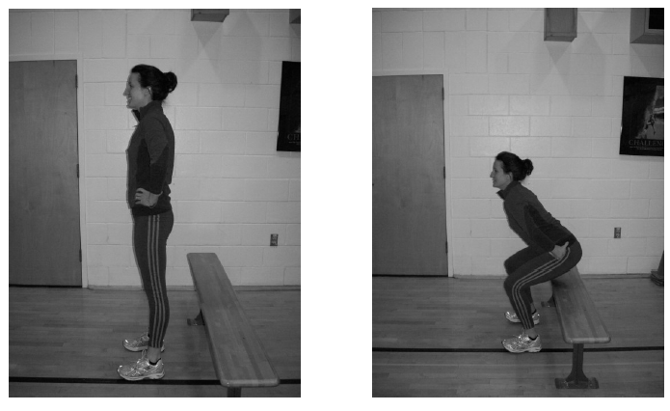

Directions:
- Have the participant stand with feet shoulder width apart.
  - Optional – Stand in front of a chair or bench (The size of the chair or bench should be one that makes the knees at right angles when sitting.)
- Hands placed on the hips or stretched out in front.
- Lower body down until thighs are parallel to the ground, keeping chest and head up and eyes looking forward. This is continued non-stop for 60 seconds or participant terminates the test.
  - Be sure knees do not extend out past toes and chest and shoulders
  - If using the bench squat down until participant lightly touches the chair with the buttock before standing back up.
- Record the number of squats completed in 60 seconds.

60 second Push-Up Test

The push-up test score is an indicator of your upper-body and shoulder muscular strength and endurance. In the standard push-up test, the participant pushes his body up and down using muscles in the arms, shoulders and chest, while keeping the body straight with the feet serving as the pivot point. The body weight is your workload. Alert! If the participant has shoulder, elbow, or wrist pain, doing this test may aggravate the condition.

Equipment:
- Mat
- Stop watch

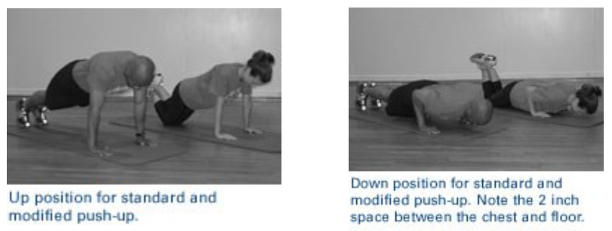

Directions:
- Start in the standard push-up position (elevated). Hands should be shoulder width apart, arms extended straight out under the shoulders, back and legs in a straight line, and toes curled under.
  - For modified push-up with knees bent and touching the floor. Starting in the up position, hands should be slightly ahead of the shoulders so hands are in the proper position for the downward motion.
- Lower until the chest is about 2 inches from the floor and rise up again.
- The participant should aim to complete as many push-ups as possible in 60 seconds.
- The participant can take a brief rest in the up position not lying on the floor.
  - Participant will perform the test until he or she cannot complete any more push-ups or maintain proper form.

60 second Half Sit-Up Test

The half sit-up test is mainly an indicator of abdominal muscular strength and endurance. Low abdominal muscular strength and endurance may lead to muscle fatigue and may lead to back injury.

Equipment:
- Mat
- Stopwatch

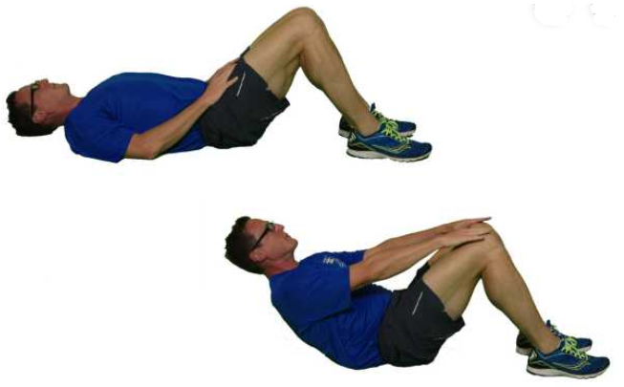

Directions:
- Have the participant lie face-up on mat with knees at a right angle (that is, 90º) and feet flat on the ground. The feet are not held down.
- The palms are facing down on the participant’s thighs.
- The lower back should be flat on the mat.
- The participant does a half sit-up so that his or her fingers touch the top of their knees.
- The shoulders are then returned to the mat and the movement is repeated as described.
- The participant’s head does not have to touch the surface.
- The lower back should be kept flat on the mat during the movements – if the back is arched, it can cause injury.
- Count the number of half sit-ups performed in 60 seconds.
- Record the results.

The Sit-and-Reach Test

This test measures the flexibility of the hips and trunk. Often times many individuals who do a lot of sitting during the day tend to be extremely tight in this area of the hips and trunk. The hips and trunk are very important for freedom of movement and general posture. Alert! If the participant has low-back pain, doing this test may aggravate the condition.

Equipment
- Mat
- Tape measure or yardstick
- Tape

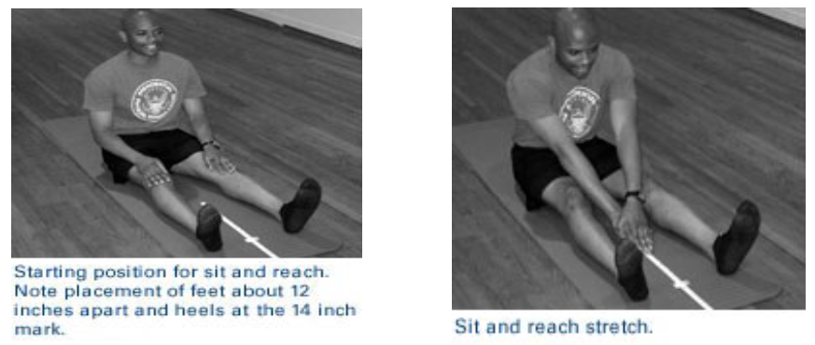

Directions:
- Place a yardstick on the floor and put a long piece of masking tape over the 15 and 32 inch marks at a right angle to the yardstick.
- Remove your shoes and sit on the floor with the yardstick between the legs (0 mark close to participant) with your feet about 12 inches apart. Heels should be at the 14 inch mark at the start of the stretch to account for the fact that the legs tend to move forward when performing the stretch.
- With the fingertips in contact with the yardstick, slowly stretch forward with both hands as far as possible noting where the fingertips are to the closest quarter inch.
  - Exhaling when you stretch forward and dropping the head may allow you to stretch a bit further.
- Do not use fast and sudden motions, which can injure your hamstring muscles.
- Perform the stretch three times with a few seconds of rest between stretches.
- Record the best measurement.

* The sit and reach test is re-printed from the YMCA Fitness Testing and Assessment Manual, 4th edition, 2000, 60606.

